**Disciplined Entrepreneurship Workbook**

# Step 16: Set Your Pricing Framework

## Worksheet

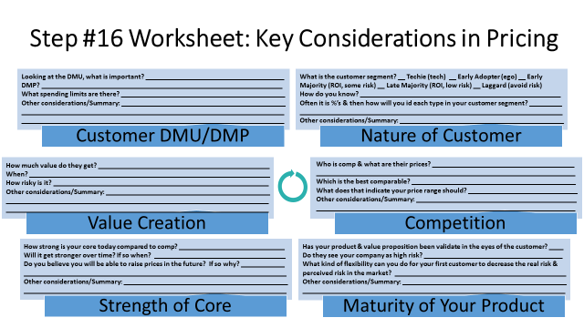

**Customer DMU/DMP**

* **Looking at the DMU, what is important?** Achieving research impact, budget efficiency, and demonstrable value are crucial for the DMU.
* **DMP?** The process involves end-user/champion advocacy convincing the budget-holding economic buyer, often navigating institutional procedures.
* **What spending limits are there?** Spending is constrained by lab/grant budgets, aligning with the previously estimated €250-€1000 per user annually.
* **Other considerations/Summary:** The Champion plays a key role in justifying the expenditure to the Economic Buyer. University procurement processes can add complexity and time to the decision.

**Nature of Customer**

* **What is the customer segment?** __ Techie (tech) __ Early Adopter (ego) __ Early Majority (ROI, some risk) __ Late Majority (ROI, low risk) __ Laggard (avoid risk) Early Adopter (ego/innovation-driven, seeks efficiency/edge) based on Step 4 and Persona.
* **How do you know?** The beachhead market definition (Step 4) and Persona profile (Step 5) target researchers actively using AI and seeking cutting-edge tools.
* **Often it is %'s & then how will you id each type in your customer segment?** Step 4 estimated 20% are early adopters; identify them via publications, tool usage, conference activity, and expressed interest in efficiency gains.
* **Other considerations/Summary**: This segment values innovation and efficiency, willing to take some risk for significant gains. Their feedback is crucial for refining the product and validating the value proposition.

**Value Creation**

* **How much value do they get?** They gain significant value via a quantified 50% reduction in research cycle time (Step 8).
* **When?** Value is realized continuously as research tasks are performed using the platform (Step 15).
* **How risky is it?** There is moderate adoption risk concerning trust in AI outputs, mitigated by human oversight features (Step 10, 15).
* **Other considerations/Summary:** The core value aligns directly with top researcher priorities identified in the Persona (Step 5). The AI's self-improving nature means the value delivered should increase over time (Step 10).

**Competition**

* **Who is comp & what are their prices?** Competitors include Google's Co-Scientist, Sakana, OpenAI DeepResearch (Step 11), with comparable prices estimated at €500–€1000/user/year (Step 4).
* **Which is the best comparable?** OpenAI DeepResearch might be the closest comparable due to its use of reinforcement learning (Step 11).
* **What does that indicate your price range should?** This suggests a viable price range of €250-€1000 per user per year (Step 4, Step 15).
* **Other considerations/Summary:** Our core provides a differentiation against static systems (Step 10). Our competitive positioning focuses on excelling in both research acceleration and quality enhancement (Step 11).

**Strength of Core**

* **How strong is your core today compared to comp?** Our core (self-improving AI via continuous learning from real research outcomes) is unique compared to competitors' potentially static systems (Step 10).
* **Will it get stronger over time?** **If so when?** Yes, it strengthens continuously over time as more real-world research data is processed, creating a data network effect (Step 10).
* **Do you believe you will be able to raise prices in the future? If so why?** Yes, because the core's self-improvement directly increases the value delivered to the customer over time (Step 10).
* **Other considerations/Summary:** The core directly enables the unique value proposition and supports the upper-right competitive positioning (Step 11). Its defensibility grows through the accumulation of proprietary learned strategies from diverse research outcomes.

**Maturity of Your Product**

* **Has your product & value proposition been validated in the eyes of the customer?** Yes, initial validation occurred through positive Persona feedback (Step 7) and high interest from the Next 10 Customers (Step 9).
* **Do they see your company as high risk?** Yes, as a new startup venture, the company itself is perceived as higher risk.
* **What kind of flexibility can you do for your first customer to decrease the real risk & perceived risk in the market?** Offer pilot programs, extended free trials, significant early adopter discounts, dedicated support, and flexible initial terms.
* **Other considerations/Summary:** Building trust early through transparency and strong support is crucial. Success stories from initial customers will be vital for reducing perceived risk for later adopters.

1. **Initial Decision and Rationale**
2. **What unit of product are you using for pricing (carried forward from Step 15, Design a Business Model)?**

 We are using a Tiered Subscription per Named User seat as the primary pricing unit, chosen for its predictability, simplicity, and alignment with SaaS norms in the academic market.

1. **Based on your analysis, what is the price range that is most appropriate and why?**

The most appropriate price range is €250 - €1000 per user per year. This range is supported by TAM analysis (Step 4), competitor pricing insights (Step 4), and balances the significant value provided (Step 8) against academic budget realities.

1. **In the first year, what do you believe your initial listed price will be, and what will be the effective price to the market and why? (The “effective price” is the actual price your customer pays after discounts.)**  
     
   We anticipate an initial listed price for a mid-tier subscription around €500 per user per year. However, the effective price will likely be lower, perhaps €250-€400 per user per year, due to early adopter discounts, pilot program pricing, or introductory offers designed to reduce risk perception and encourage initial adoption.
2. **Sanity Check: What is your expected estimated marginal cost (cost to produce a unit of product, excluding one-time setup costs)? Does your price per unit significantly exceed your estimated marginal cost in the long term?**

The estimated marginal cost per additional user is very low, primarily consisting of incremental cloud hosting and support costs, approaching near-zero. Yes, the anticipated price per unit significantly exceeds the marginal cost in the long term, consistent with typical software-as-a-service business models.

1. **Test to Validate**
   1. **In setting your pricing framework, what hypotheses are you assuming to be true?**

We hypothesize that:   
1) Researchers perceive enough value to justify an annual cost of €250-€1000 per user.   
2) A predictable, per-user subscription model is preferred over usage-based models.   
3) Tiered pricing effectively captures different user needs and willingness to pay.

* 1. **What experiments will your run to test your hypotheses?**   
       
     We will offer clearly defined subscription tiers (e.g., Basic, Pro, Premium) at different price points during our beta program and initial launch. We will monitor uptake rates, tier choices, and actively solicit feedback on pricing perception through surveys and interviews with early users.
  2. **What information will show that your hypotheses are valid or invalid?**  
     Validation will come from achieving target conversion rates to paid tiers, observing user distribution across tiers matching expected value, receiving positive feedback on price fairness relative to value, and achieving revenue per user aligning with projections. Invalidation would be indicated by low conversion, clustering in free/lowest tiers, strong negative feedback on price, or significant deviation from revenue goals.
  3. **How long will you give the experiments to run?**

We will allow these initial pricing experiments to run for approximately 3 to 6 months following the initial launch or during the dedicated beta testing phase to gather sufficient data and observe user behavior patterns.